Lab Exercise 2- Single Node, 4-Drive MinIO Cluster
Objective:
Deploy a MinIO cluster on a single server using 4 drives, simulate disk failure, observe healing + rebalancing, and restore the drive.

Prerequisites
- Ubuntu 20.04/22.04
- sudo privileges
- Latest MinIO binary installed:

Rocky Linux:
sudo dnf update -y
sudo dnf install -y wget unzip

wget https://dl.min.io/server/minio/release/linux-amd64/minio
chmod +x minio
sudo mv minio /usr/local/bin/

STEP 1 — Create 4 Loopback Disks
We will create 4×5GB virtual disks.
sudo mkdir -p /minio-disks

cd /minio-disks
sudo fallocate -l 1G disk1.img
sudo fallocate -l 1G disk2.img
sudo fallocate -l 1G disk3.img
sudo fallocate -l 1G disk4.img

Create loop devices:
sudo losetup -fP /minio-disks/disk1.img
sudo losetup -fP /minio-disks/disk2.img
sudo losetup -fP /minio-disks/disk3.img
sudo losetup -fP /minio-disks/disk4.img

Verify loop devices:
losetup -a
You will see something like:
/dev/loop3: [xxxx] disk1.img
/dev/loop4: [xxxx] disk2.img
/dev/loop5: [xxxx] disk3.img
/dev/loop6: [xxxx] disk4.img

STEP 2 — Format Disks as XFS
sudo mkfs.xfs -f /dev/loop3
sudo mkfs.xfs -f /dev/loop4
sudo mkfs.xfs -f /dev/loop5
sudo mkfs.xfs -f /dev/loop6

STEP 3 — Create Mount Points
sudo mkdir -p /mnt/data1
sudo mkdir -p /mnt/data2
sudo mkdir -p /mnt/data3
sudo mkdir -p /mnt/data4

Mount all disks
sudo mount -o rw /dev/loop3 /mnt/data1
sudo mount -o rw /dev/loop4 /mnt/data2
sudo mount -o rw /dev/loop5 /mnt/data3
sudo mount -o rw /dev/loop6 /mnt/data4

sudo chown -R ubuntu:ubuntu /mnt/data1
sudo chown -R ubuntu:ubuntu /mnt/data2
sudo chown -R ubuntu:ubuntu /mnt/data3
sudo chown -R ubuntu:ubuntu /mnt/data4

STEP 4 — Ensure All Drives Are Empty
(MinIO refuses disks with old format.json)
sudo rm -rf /mnt/data1/.minio.sys
sudo rm -rf /mnt/data2/.minio.sys
sudo rm -rf /mnt/data3/.minio.sys
sudo rm -rf /mnt/data4/.minio.sys
touch /mnt/data1/test
touch /mnt/data2/test
touch /mnt/data3/test
touch /mnt/data4/test

STEP 5 — Export MinIO Credentials
export MINIO_ROOT_USER="minioadmin"
export MINIO_ROOT_PASSWORD="Minio@12345"

STEP 6 — Start MinIO in Single Node, 4 Drive Mode
minio server \
/mnt/data1 \
/mnt/data2 \
/mnt/data3 \
/mnt/data4 \
--console-address ":9001"

What This Means:
- Single node
- 4 drives
- Erasure coding: EC:2 parity
- High durability (2 drives can fail)
You will see:
API: http://172.31.x.x:9000
Console: http://172.31.x.x:9001

Status: 4 drives online

STEP 7 — Create a Bucket & Upload Files
wget https://dl.min.io/client/mc/release/linux-amd64/mc
chmod +x mc
sudo mv mc /usr/local/bin/

mc alias set local http://localhost:9000 minioadmin Minio@12345

mc mb local/testbucket

echo "hello1" > file1.txt
echo "hello2" > file2.txt

mc cp file1.txt local/testbucket
mc cp file2.txt local/testbucket

STEP 8 — SIMULATE DRIVE FAILURE
We will unmount data3 to simulate disk failure.

mc admin info local

sudo umount /mnt/data3

Check MinIO:
mc admin info local
You will see:
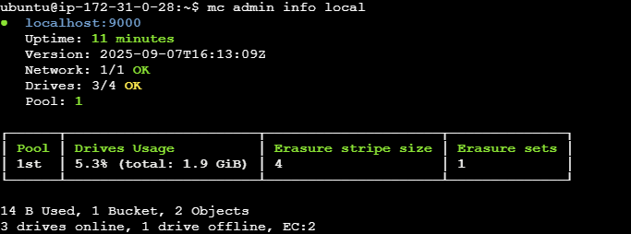
Healing triggered for objects
MinIO continues working (because 1 drive failure is tolerated).

STEP 9 — Observe Healing Status
mc admin heal -r local/testbucket

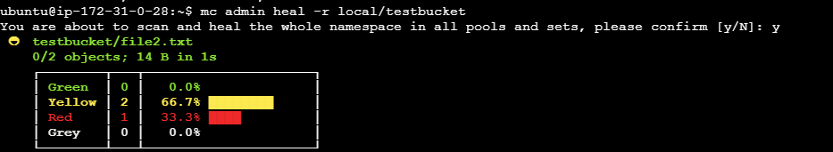

STEP 10 — REATTACH THE DRIVE (simulate fixing the disk)
Remount the disk:
sudo mount /dev/loop5 /mnt/data3

Check MinIO logs:
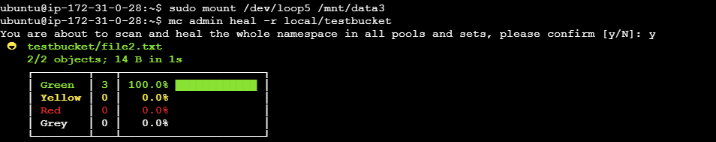
mc admin info local

